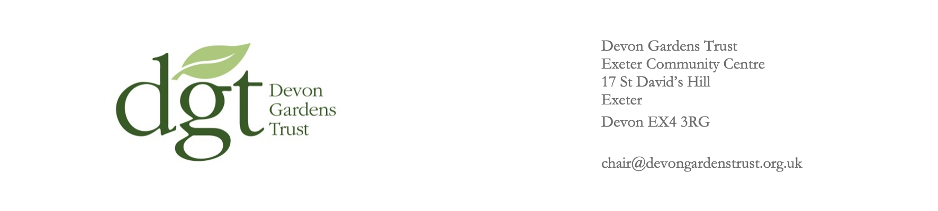

COMMUNITY GRANT APPLICATION FORM

- Project Title:

- Name and address of applicant:
Name of applicant
Address
Website
Social media

- Contact person:
Name
Position
Email address
Tel. number

- Is the organisation a registered charity? YES / NO

If yes, please give charity number
- Organisation description: Describe its aims and provide details of financials/accounts and staffing
200 words maximum

- Project description: Describe the proposed project and how it will be managed - key tasks, timetable and project team (photos & drawings can be submitted as attachments)
500 words maximum

- Project benefits: What do you hope to achieve and who will benefit from this project?
300 words maximum

- How will the applicant measure and monitor the success of the project?
200 words maximum

- Proposed start date of the project:

- Anticipated completion date of the project:

- Cost of project, please provide the cost breakdown of principal expenditure items and the total amount you are applying for: (maximum grant is £5,000)

Total cost (incl. VAT)
Cost breakdown
Amount requested

- Has any other funding been applied for or granted for this project? YES / NO

If so, how much and from whom:

- Is Planning Approval needed for this project? (This might include Listed Building Consent and Tree works within Conservation Areas also require consent.) YES / NO

If so, please enclose a copy, or copies, of any consent obtained

Project representative’s signature:

Date:

We have two grant rounds per year. Applications must be submitted by 30th June or 31st December. Applicants will be notified by the end of following July or January.

Send completed application form to: chair@devongardenstrust.org.uk

